

Technical Resilience Standards
Published: 26th January 2026
v0.5

We are responsible for improving and protecting the environment. We aim to grow a green economy and sustain thriving rural communities. We also support our world-leading food, farming and fishing industries.
Defra is a ministerial department, supported by 34 agencies and public bodies.

© Crown copyright 2025
This information is licensed under the Open Government Licence v3.0. To view this licence, visit www.nationalarchives.gov.uk/doc/open-government-licence/
Where we have identified any third party copyright information you will need to obtain permission from the copyright holders concerned.
This publication is available at www.gov.uk/defra
Any enquiries regarding this publication should be sent to us at guardrails@defra.gov.uk or via this feedback form: Technology Guardrails Service - Guardrail Feedback – Fill in form

Contents
Technical Resilience Standards 1
Version Control 4
Reviewers 4
Approval 4
Document owner 5
Purpose 5
Alignment to Service Tiers for Support 7
IT Service Management Support Offering 8
Technical Standards – Section A (Non-Functional Requirements) 8
Technical Standards – Section B (Patterns and Options) 10
Security Log Storage Recommendations 13
Multi-cloud and Hybrid Deployments 13
Definitions 13
Governance 15

Version Control
Version | Date | Changes | Author(s)
0.1 | 21/07/2025 | Initial creation | Hannah Radley & Joel Smith
0.2 | 05/09/2025 | Following review from Cloud Working Group: Amended RTO/RPO and availability levels. Added additional guidance | Hannah Radley & Joel Smith
0.3 | 23/10/2025 | Added additional clarification | Hannah Radley
0.4 | 09/02/2026 | Renamed from Technical Standards for Service Tiering to Technical Resilience Standards following recommendation at TGB | Hannah Radley
0.5 | 16/04/2026 | Updated definition of availability for clarity | Hannah Radley

Reviewers
Name | Role
Daniel Ingram | IT Service Continuity Manager
Louise Hickman | Service Strategy Lead
Andy Barker | Service Readiness Manager
Andy Swift | Senior Infrastructure Technical Lead

Approval
Name | Role
Paul Mukherjee | Chief Technology Officer
Richard Howells | Head of Strategic Architecture
Adam Shaw | Principal Cloud Architect
Duncan Baird | Principal Infrastructure Architect

Document owner
Name | Role
Hannah Radley | Lead Enterprise Architect

Purpose
This document outlines the minimum non-functional requirements for all new services and for existing services undergoing redesign.
- For new services: This standard should be reviewed after the service tier has been assessed but before the design phase begins, so that requirements can be built into the solution. Guidance on how to assess service tiers can be found here: Service Tiering
- For existing services: If no change in service tier is expected, this standard should still be consulted before the design phase to ensure any architectural changes align with current requirements. Services originally designed before this standard was introduced must be updated to comply.
Caveats:
- Where centrally or supplier managed, these standards will still apply, but the suppliers retain flexibility in how the underlying infrastructure is implemented and operated. If a third party applies their own standards, this would need to be captured, and any potential risk accepted by the service owner
- Service tiering is determined at the overall service level. However, individual components within the service may vary in criticality and, depending on their purpose, could tolerate lower levels of availability or resiliency. These considerations should be discussed with relevant architects during the design phase. Ultimately, the service, as a whole, must meet the defined availability requirements
- Internal business services should be 24/7 but can tolerate larger periods of non-availability for service maintenance (e.g. Power BI reports might not be available for a period of time each day because underpinning data are being refreshed, or services might be being backed up and need to remove access to all to ensure a clean backup). Those periods of downtime need to be published on a service-by-service basis depending on the needs of the business

Alignment to Service Tiers for Support
This document complements the main Service Tiering Framework, which outlines the operational support provided at each tier. However, it serves a distinct purpose: to define the architectural standards required to build services that align with different tiering levels. While some services may require similar levels of operational support, their availability and resiliency needs can vary. This distinction is reflected in the separation of Tier 1 into Tier 1a (mission critical) and Tier 1b (enhanced support). The appropriate classification should be determined by the business, in consultation with the architecture team, based on an assessment of acceptable risk in the event of service downtime. The availability targets are set regardless of support hours.

IT Service Management Support Offering

Managed by Group Infrastructure and Operations

Technical Standards – Section A (Non-Functional Requirements)
 | Tier 1a  (Mission-Critical*) | Tier 1b  (Enhanced Support) | Tier 2  (Standard Support) | Tier 3  (Standard Support) | Tier 4  (Standard Support)
Availability | 99.95% | 99.9% | 99% | 95-98% | 90-94%
Resiliency – cloud (AWS or Azure) | Regional Redundancy | Zonal Redundancy | Zonal Redundancy | Backups dependent on service needs
Resiliency – on-premises | Active-Active across 2 data centres in separate geographical regions | Active-Passive across 2 datacentres | 2 datacentres, with cold-standby, using data sync (e.g. log shipping) to maintain data currency with a full archival refresh weekly | 2 datacentres, with cold-standby, using data sync (e.g. log shipping) to maintain data currency with a full archival refresh monthly | Single datacentre reliant on backups
Recovery Time Objective (RTO) | 5 mins – 2 hours | 2 – 4 hours | 4-8 hours | 8 – 48 hours | 2 – 30 days
Recovery Point Objective (RPO) | 0mins – 2 hours |  | 2 – 8 hours | 8 – 48 hours**
Permitted unavailability (hours/minutes in a 28-day period) | 21minutes | 40.32minutes | 6 hours and 43 minutes | 13 hours and 26 minutes – 33 hours and 36 minutes | 33 hours and 36 minutes - 67 hours and 12 minutes
Service Continuity Testing | Annually and/or after major upgrade |  |  | Every 3 years and/or after major upgrade | After major upgrade
Te | Patching managed by supplier |  | Where not managed by supplier:  Monthly security patching  Quarterly feature patching |  | Where not managed by supplier:  Monthly security patching,  6-monthly feature patching
SOC | Connection to SOC determined by Security Business Impact Assessment
Security event logs | Kept available for minimum of 2 years – see table below for storage recommendations
Connectivity | No single point of failure in connectivity path |  | Asymmetric redundant routes | Standard connectivity offer
*For applications that score 5 across all ratings on the Business Impact Assessment
**Depending on backup frequency and individual application requirement
For cloud-based solutions not on either AWS or Azure, guidelines will be set at the discretion of the Solution Design Authority or Technical Design Authority

Technical Standards – Section B (Patterns and Options)
 | Tier 1a  (Mission Critical*) | Tier 1b  (Enhanced Support) | Tier 2  (Standard Support) | Tier 3  (Standard Support) | Tier 4  (Standard Support)
Cloud (AWS or Azure) | Regional Redundancy - 3 availability zones across 2 regions | Zonal Redundancy - 3 Availability Zones in 1 region | Zonal Redundancy - 2 Availability Zone in 1 region | Backups dependent on service needs
On-Premises | Active-Active across 2 data centres in separate geographical regions | Active-Passive across 2 datacentres | 2 data centres - cold standby in second datacentre with weekly data refresh | 2 data centres - cold standby in second datacentre with monthly data refresh | Single datacentre reliant on backups
*For applications that score 5 across all ratings on the Business Impact Assessment

Example Patterns (full reference architecture in appendices)
Tier 1a
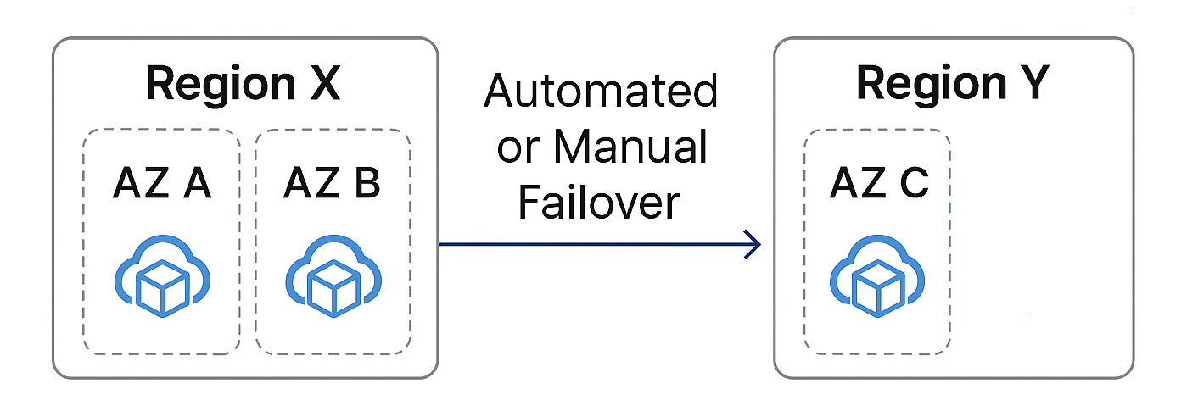

Tier 1b
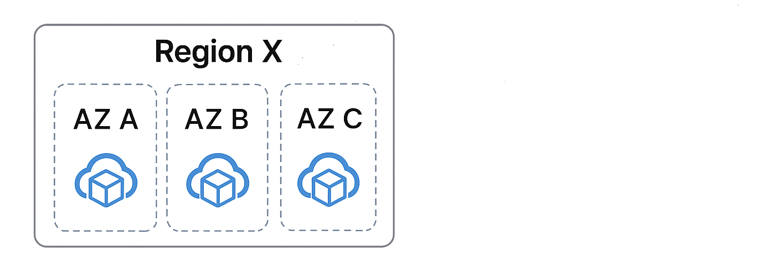
Tier 2
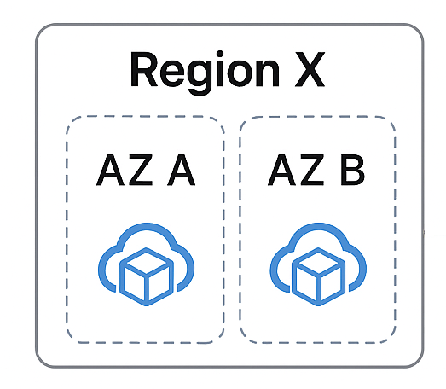
Tiers 3 and 4
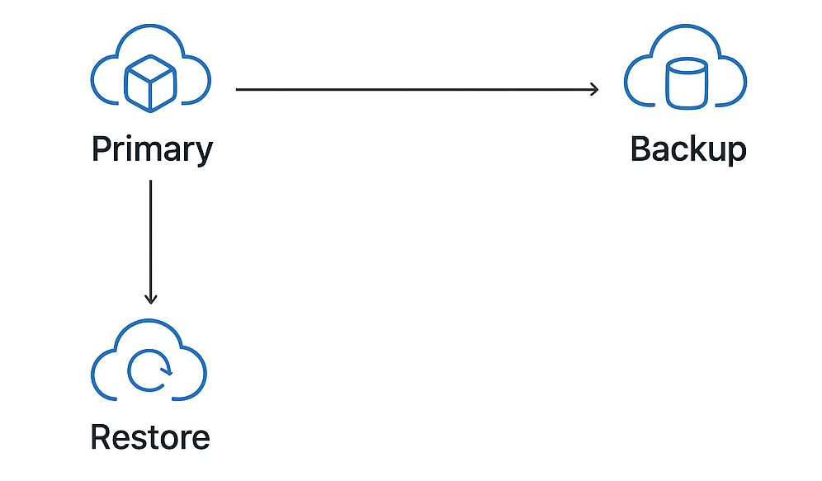

Security Log Storage Recommendations
Tier | Hot (immediate access) | Cool (lower cost, slower access) | Cold (rare access)
1 | 90 days | 24 months | 12 months
2 | 60 days | 6 months | 12 months
3 | 14 days | 3 months | 6 months
4 | 2 days | 1 month | 3 months

Multi-cloud and Hybrid Deployments
As outlined in the caveat section of this document, the level of resiliency, availability, and security required depends on the criticality of the specific component. For example, if a cloud service relies on an on-premises reach-back, it is up to the architect and the business to assess and agree on the level of risk they are willing to accept for that component. This decision should be made collaboratively, provided that the overall service still meets the minimum acceptable standard for availability and resiliency. In addition, supporting services (e.g. FortiGate) must match the resilience of the primary service.

Definitions
Availability: Availability describes the overall, steady‑state uptime of a service in terms of its ability to remain accessible and operational to users during normal operation over a defined measurement period (28 days in this case). It is typically expressed as a percentage, representing the proportion of total time the service is available compared to the total time in that period.
Availability captures general service uptime and includes all causes of unavailability within the measurement window (excluding agreed planned downtime, where applicable). It is distinct from incident‑specific recovery measures, such as Recovery Time Objective (RTO) and Recovery Point Objective (RPO), which describe how quickly a service is restored and how much data may be lost following a disruptive event. This is the total availability target regardless of support hours
Permitted Unavailability (28‑day period): The maximum cumulative time a service may be unavailable within a 28‑day period. This measure relates to local fault recovery as part of High Availability (HA) design, rather than end‑to‑end recovery from major incidents. This is distinct from RTO and RPO, which define recovery objectives following disruption.
Active-Active: two or more applications running at the same time, doing the same job. If one application fails, the others keep working without any interruption.
Active-Passive: one application is doing all the work (active), while another is on standby (passive), ready to take over if something goes wrong. There may be a slight delay if the main system goes offline before the standby applicaton is able to pick up the work.
Recovery Time Objective (RTO): maximum amount of time an application or service can be down after a failure before it needs to be back up and running
Recovery Point Objective (RPO): how much data you can afford to lose if something goes wrong. It’s the maximum amount of time between your last backup and a failure. For example, if your RPO is 1 hour, then you should be okay losing up to 1 hour of data in a worst-case scenario.
Major Upgrade: significant change or enhancement that impacts the service's functionality, architecture, performance, or user experience. It goes beyond routine maintenance or minor patches and often requires careful planning, testing, and communication
Cloud Region: a physical area where a cloud provider (like Microsoft, Amazon, or Google) has data centres. These data centres store and run your apps, files, and services. Choosing a cloud region close to you can make things faster and help meet legal or security requirements. Having two cloud regions means there are two locations where your apps, files and services are stored so if there is an outage in one region, the other region will ensure there is no interruption in your service.
Cloud Availability Zone: within a region, there are individual clusters of data centres. Each zone has its own power, cooling, and network, so if one zone has a problem, the others can keep working. It has less resiliency than regions as if something affects the whole region, you will have no backup but more resilient than a single instance.

Governance
Formal governance processes are currently in development. In the meantime, please reach out to us if you are unable to meet any of the requirements.
SLAs and availability will need to be documented as part of Service Readiness and onboarded onto ServiceNow as a new service or as an amendment to an existing service as required (future process).

